# CS 255 System Design Document Template

## UML Diagrams

### UML Use Case Diagram

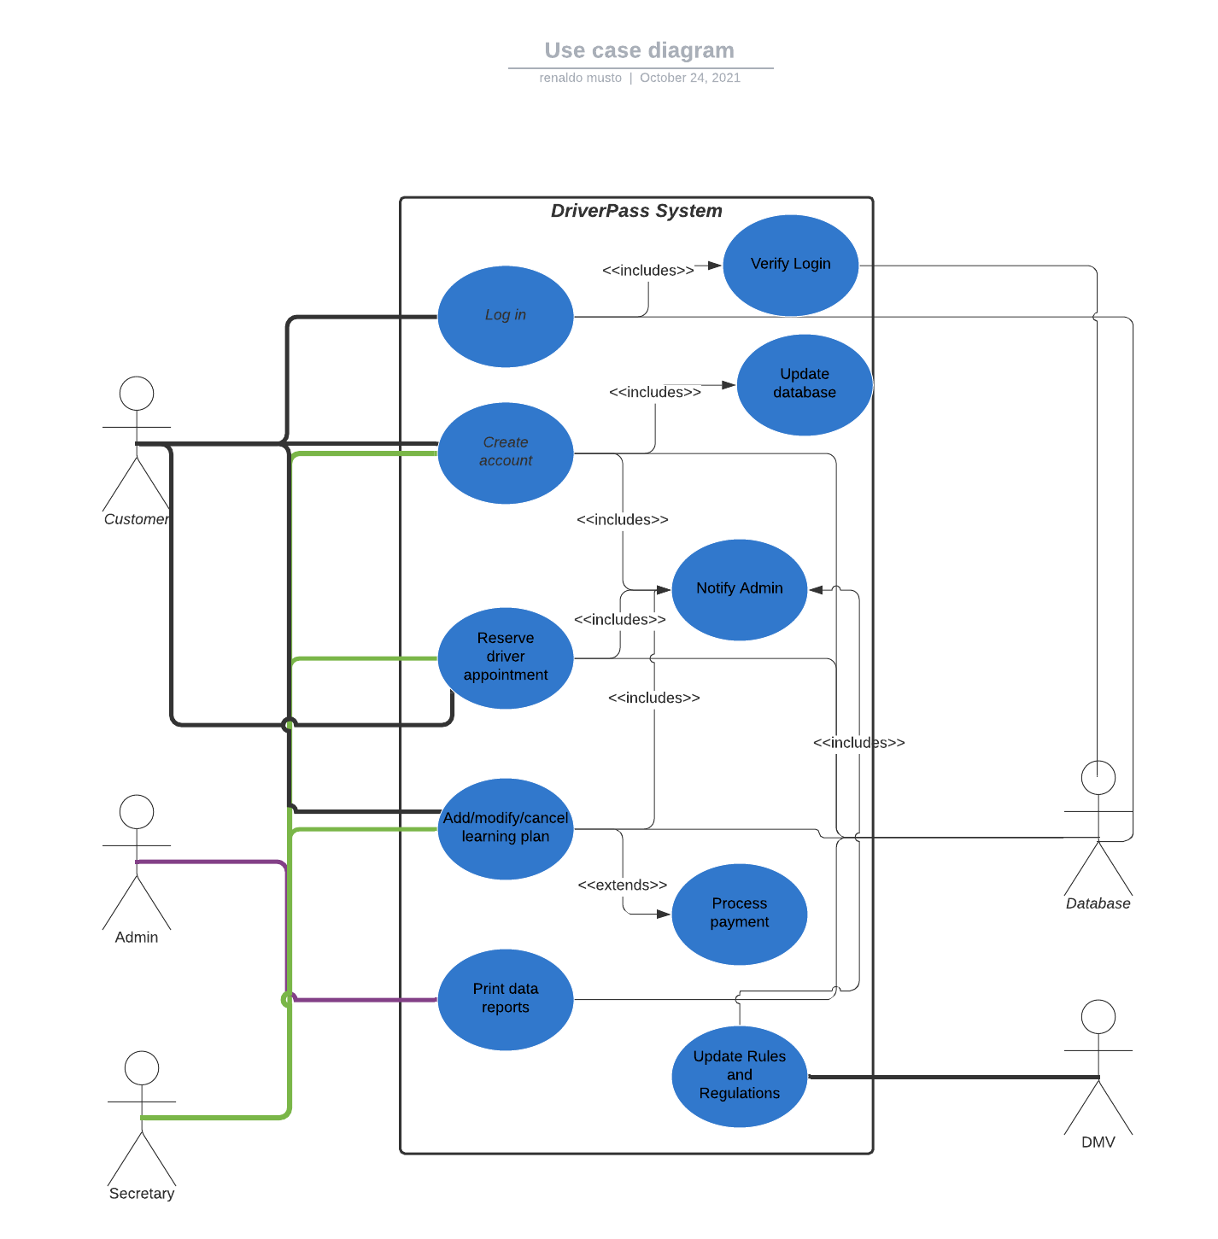

### UML Activity Diagrams

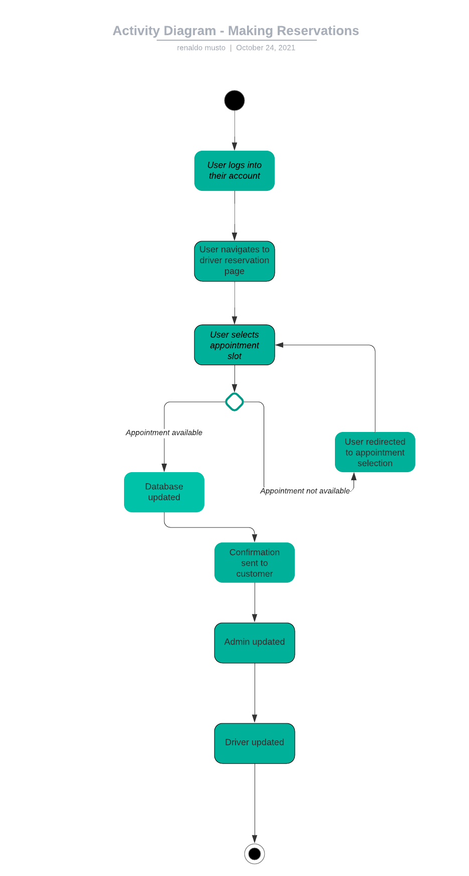

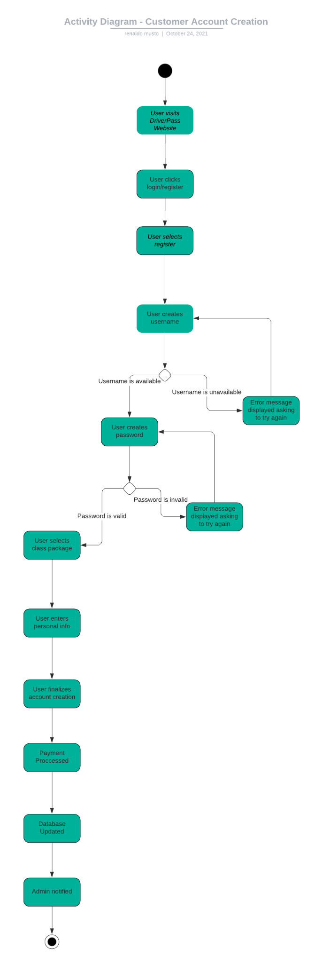

### UML Sequence Diagram

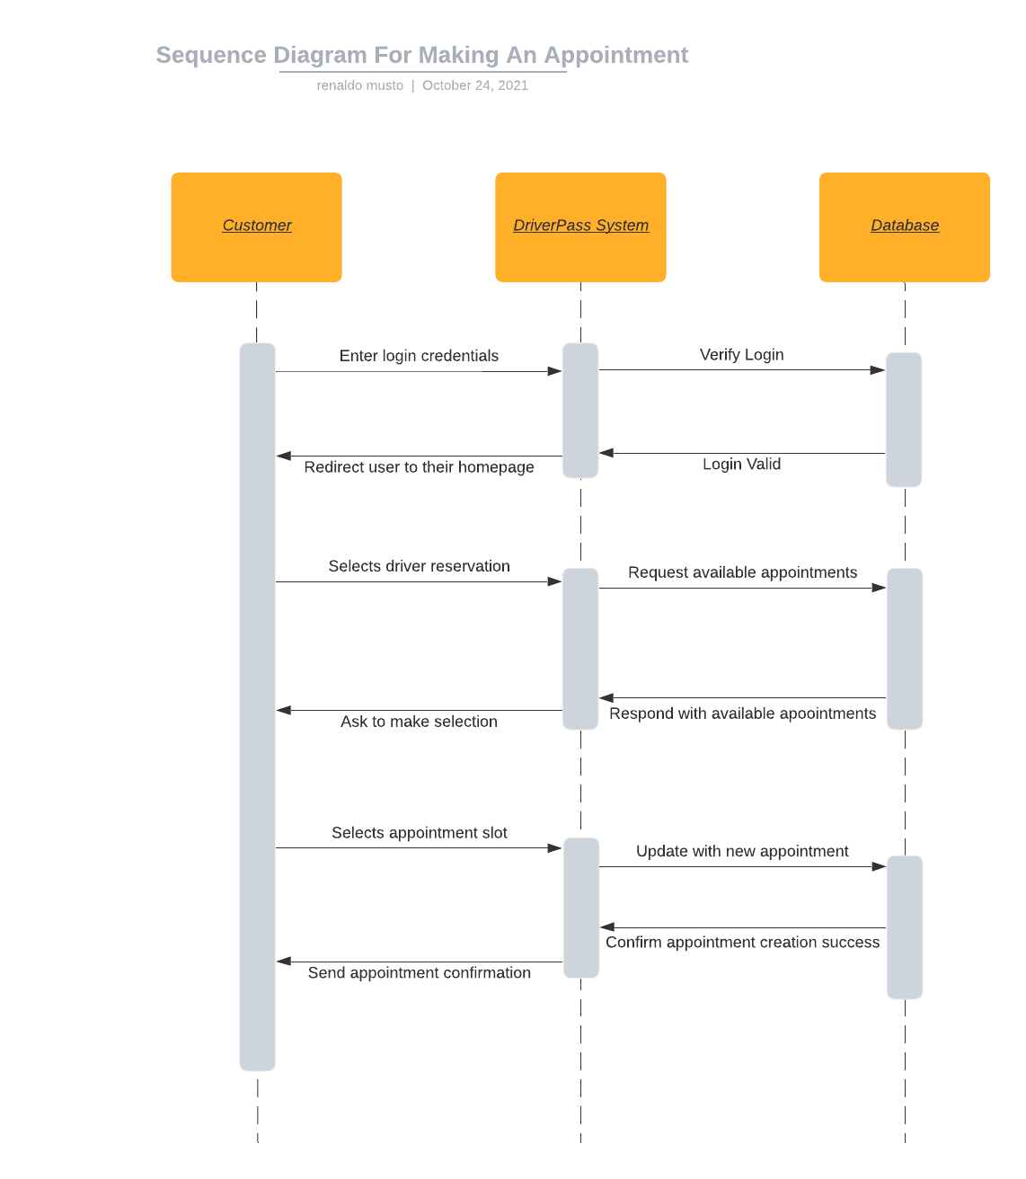

### UML Class Diagram

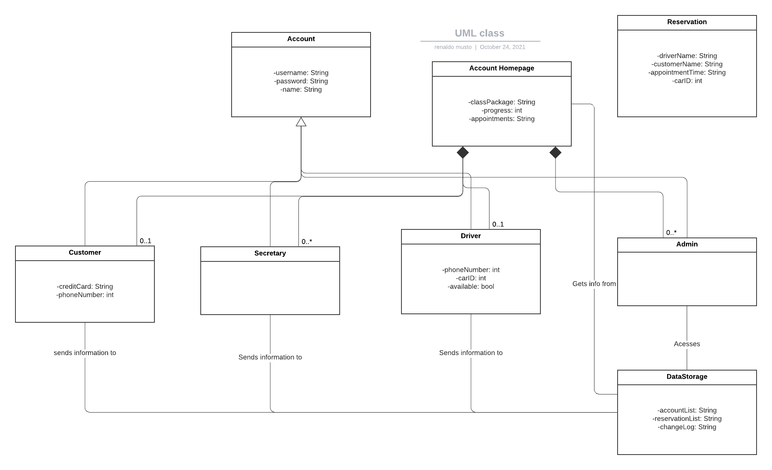

## Technical Requirements

Since our system will primarily be hosted remotely on a cloud server we will not need a lot of physical infrastructure in the office to support this system. We will need a computer that is capable of running the website for each individual at the company and sufficient internet access speeds. The computers will need to be running one of the major operating systems such as Windows and use a widely supported internet browser such as Google Chrome. It would probably be a good idea for the IT department to keep a basic computer repair kit in case something goes wrong. The secretary will also need a phone to be able to answer calls and create accounts for customers. The admins computer especially should have plenty of storage space so they can download and store backups of whatever they want from the system.